Rachel Mann

Rachel Mann is a parish priest, poet and theologian based in South Manchester. Author of three books, her account of growing up trans, ‘Dazzling Darkness’, was a Church Times bestseller.
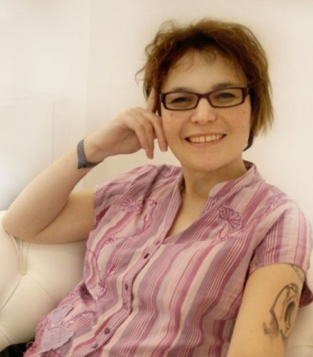
A regular contributor to BBC Radio 2’s Pause for Thought, she also broadcasts on subjects of gender, sexuality and ill health. She is currently Poet-in-Residence at Manchester Cathedral.

