Lance Blake MA TSSF Conference Chaplain.

Franciscan Hermit from The Fenland Hermitage.
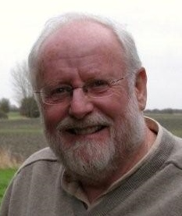
Lance was a Franciscan Friar who found a second vocation in Chaplaincy working in General, Military and Mental Health Hospitals before completing 14 years as a Hospice Chaplain, much of that time on the AHPCC Executive before returning to his contemplative roots as a hermit providing Spiritual Direction and other resources to the Diocese of Lincoln.

