Karen Elsworth BSc (Phys) MCSP MHCP MA (Theology and Ministry)

Chartered Physiotherapist, Craniosacral Therapist, Holistic Integrated Practitioner.
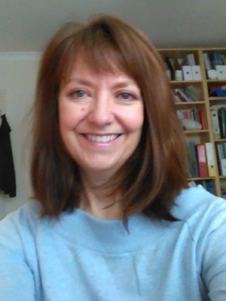
Karen is an independent physiotherapist working in the area of chronic and complex pain treatment and management; she is also weekend chaplain at Hospice in the Weald.

