Children’s stories that have been used in memorial services

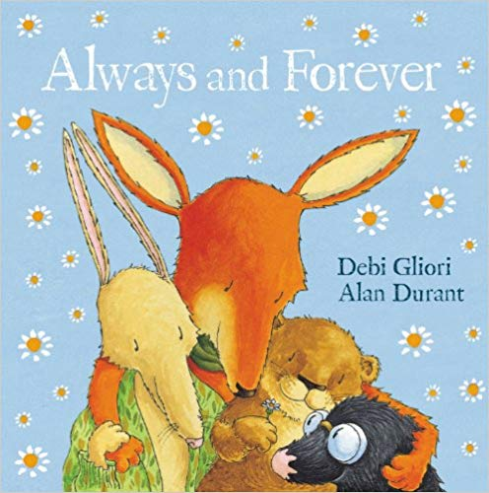
Always and forever
Alan Durant and Debi Gliori (2013)
Picture Corgi
After Fox dies, his friends Hare, Mole and Otter begin to learn to appreciate their memories of him as he really was.

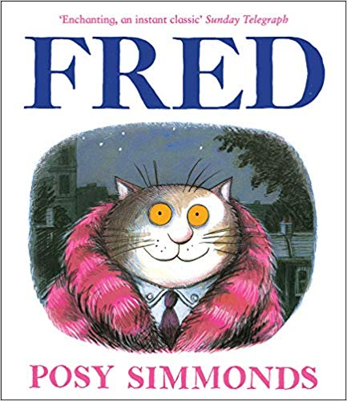
Fred
Posy Simmonds (2014)
Andersen
It is only after Fred the cat dies, that his ‘owners’ Nick and Sophie discover his true identity, and appreciate who Fred really was.

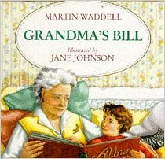
Grandma’s Bill
Martin Waddell (1995)
Hodder
When Bill looks at his grandma’s photo album, he learns that old people were young, once.

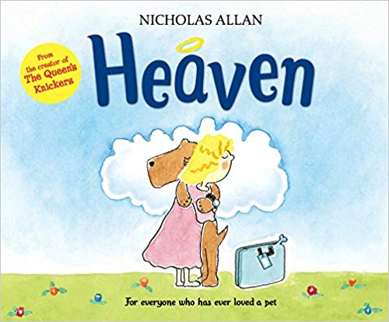
Heaven
Nicholas Allen (2014)
Red Fox
Dill the dog is about to go to heaven, and it’s time to say goodbye to Lily – but what is heaven like? They both have very different ideas!

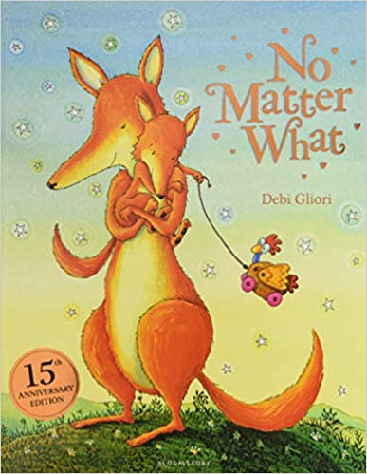
No matter what
Debi Gliori (2005)
Bloomsbury
Large reassures Small that love goes on, even after death.
(NB we highly recommend the 2005 edition, as the words and meaning have been changed)

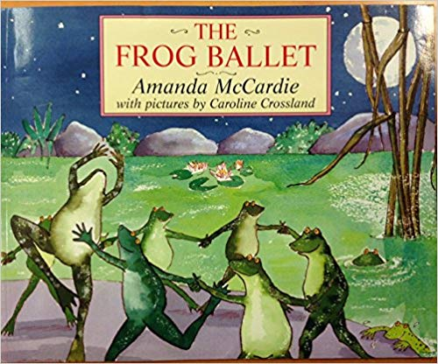
The Frog Ballet
Amanda McCardie and Caroline Crossland (1997)
Jonathan Cape
The Old Frog is far from well, and the younger frogs do their best to cheer him up, but then realise they must say goodbye.

