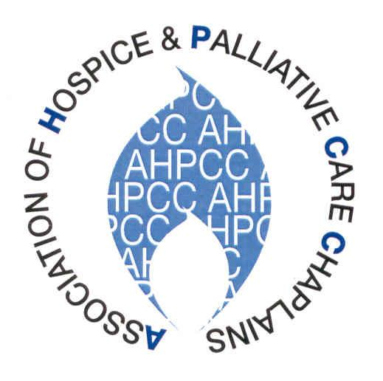
Rev Judy Davies
Sue Ryder – Duchess of Kent Hospice
22 Liebenrood Road
Reading RG30 2DX
Tel: 0118 9550498

president@ahpcc.org.uk

January 2014

Dear Friends,

Greetings to you all! In particular, I want to offer a welcome to those of you who are new in post, or new to the AHPCC. I hope that you will find belonging to the Association a source of colleagueship and support, as well as practical assistance to you in your work.

For those of you who haven’t yet renewed your membership, an application form is attached for your convenience. As agreed at our last AGM, we have made a modest increase in the membership fee (from £30 to £35), but I hope that you’ll feel this is good value. You will more than recoup the fee with your members’ discount if you attend our annual Conference.

I want to encourage you to come to Conference in May 2014. We have responded to specific suggestions in the feedback from last year, and this time we will be looking at the particular challenges presented by dementia and other progressive neurological conditions. We will aim as always to provide food for thought through our keynote speakers and workshops, but there will also be plenty of informal opportunities for people to chat and learn from one another. Our Conference poster is on the website, and further information will be coming out at the end of February from our Conference organisers Dawn Allan and Tom Duncanson.

Many of you will be aware that there have been some interesting developments in the past year for healthcare chaplaincy. I’ll write about this in more detail in my pre-Conference President’s report; but broadly speaking, representatives of Chaplaincy organisations are at present engaged in conversations with NHS England. We want to provide a united voice for Chaplaincy to ensure that spiritual care is at the heart of future healthcare provision. Some of the issues we are tackling at present include revision of the 2003 NHS Guidelines for Chaplaincy-Spiritual Care, and looking again at guidance around the Data Protection Act, to try to ensure that chaplains are not marginalized by the way the Act is applied.

You’ll find details about everything that’s happening on our website: just click on Study and Policy and then follow the link to The Future of Chaplaincy. It’s easy to think this is all “dry as dust” stuff – people sitting around in meetings, when what really matters is getting on with the job. But the clue is in the title: the discussions we’re engaged in now, which may not set the pulse racing, concern the future of the work about which we all feel so passionately; and although the primary focus at the moment is England and the NHS, the outcomes will undoubtedly affect us all. So please get engaged in the process: attend consultations, respond to surveys, make your views known. My overriding concern is that you feel informed, and are as involved as you wish to be!

This brings me back to our website, which in recent years has become a major source of communication for us. We’re grateful to our website editor Mike Rattenbury and our webmaster Richard Whitehouse for updating it so efficiently. Do check the website regularly, and use the Members’ Forum and other areas to ask advice, publicise vacancies and training opportunities, and spread the word about anything you’ve found helpful in your work.

Please don’t hesitate to contact me directly if there are any chaplaincy issues that you need to discuss, and
I will do my best to respond promptly.

With every good wish to you all for the coming year,

Judy

Judy Davies
AHPCC President

